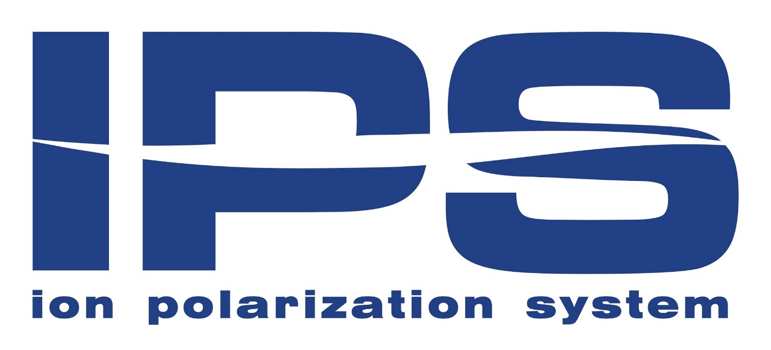
- Impact, savings, efficiency, cost

7 Benefits of IPS Physical Water Treatment Compared to Conventional Water Softeners, Cationic Treatment or Reverse Osmosis Treatment:
- PRICE: It is consider ably cheaper than a cabinet ion – exchange softener or as a reverse osmosis or cat ion exchange system.
- MAINTENANCE: The IPS system is a maintenance-free (galvanic) physical water treatment system.
- OPERATING COSTS: The IPS system does not require any external or internal parts for replacement, no expensive internal accessories, no maintenance costs.
- ENVIRONMENT: Ion Polarization System (IPS) It is environmentally friendly. No rinsing of the resin and the release of salty water into the environment, compared to competing chemical water treatment.
- KOMFORT: Simple installation + Direct connection to central water supply + Practical equipment of various dimensional sizes.
-SAVINGS: It works without an external power source for more than 7 years. We declare up to 10 years.
- TASTE OF WATER: Improves taste of water. Compared to IPS from conventional water softeners, the resin from conventional softener can release sodium, which leads to a change in the taste of water.
HEALTH: Water is softer and smoother to human skin, less shampooing. Irritations are minimized. The IPS optimally increases Ph water and produces so-called alkaline water. A great advantage is the ability of IPS to ionize water. Ionized water has a different structure than ordinary water. Water molecule segregate together, with typically 12-18 molecules bound in normal water. This amount is too large for water to reach though the cell membrane and to be properly absorbed. Only 6 molecules are bound in ionized alkaline water, which makes it much easier to transfer water to cells.
Comparison table:
 | KATEX | REV. OSMOSIS | IPS
Principle of operation: | El. energy | El. energy | -
Maintenance: | Resin 50-79 e | 60 – 79 e | -
Effect: | H2O non drinkable | H2O distilled | Increased PH of the water and taste of water
Additional costs: | Replacement of filter inserts addition of resin. | Replacement of filter inserts + regeneration filters. | -
Summary: | Cost per installation + service price + running costs = 1200 – 2000e | 1350 – 2160 e + Operating costs and service = 2200 -2500e | One-time investment when buying 400e - and more, depending on the size of the necessary dimensions.
Return: | Continuous investment associated with service low returns | Continued costs by supplementing mineralizing inserts | 6 -12 months. – Less detergents, regulation of the formation of water scale, increase of pH of water, protection against corrosion.

Efficiency of IPS from a technical point of view:
- A 3 mm layer of water scale on thermal equipment reduces their efficiency by up to 20%. For a 6 mm coarse layer, efficiency is reduced by up to 35-40%. This significantly increases operating costs.
- IPS – Conserves effort and finance associated with changing or cleaning heaters in boilers, washing machines, dishwashers, water heaters, shower trays, flushing tanks, atc.

